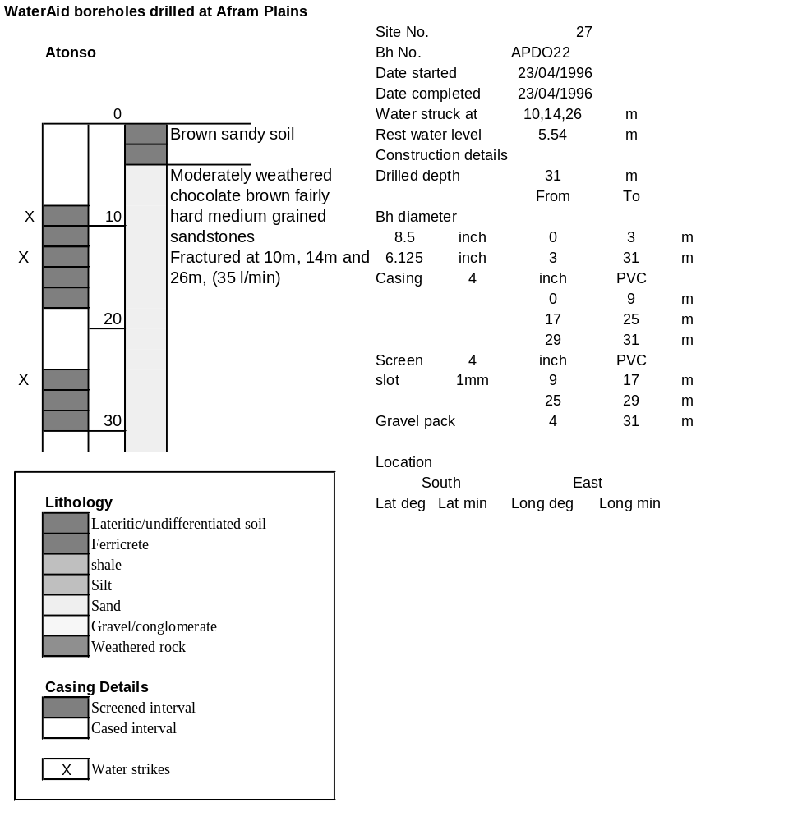

Ghana | Test pumping
Borehole No. |  | APDO22
Hole No |  | 27
Village |  | Atonso
Date |  | 26/04/1996
Point above GL |  | 0.5 | m
Pump depth |  | 27 | m
SWL |  | 6.04 | m
Start Time |  | 08:45
Drawdown test |  |  |  |  | Recovery test
time | pwl (m) | Q l/min | s (m) | sc | Time | wl (m) | s' (m) | t/t'
0.00 | 6.04 | 30.00 | 0.00 |  | 0.00 | 10.06 | 4.02
1.00 | 7.13 | 30.00 | 1.09 | 27.52 | 1.00 | 7.75 | 1.71 | 181.00
2.00 | 7.25 | 30.00 | 1.21 | 24.79 | 2.00 | 7.35 | 1.31 | 91.00
3.00 | 7.41 | 30.00 | 1.37 | 21.90 | 3.00 | 7.26 | 1.22 | 61.00
4.00 | 7.47 | 30.00 | 1.43 | 20.98 | 4.00 | 7.20 | 1.16 | 46.00
5.00 | 7.58 | 30.00 | 1.54 | 19.48 | 5.00 | 7.17 | 1.13 | 37.00
6.00 | 7.62 | 30.00 | 1.58 | 18.99 | 6.00 | 7.15 | 1.11 | 31.00
7.00 | 7.68 | 30.00 | 1.64 | 18.29 | 7.00 | 7.14 | 1.10 | 26.71
8.00 | 7.74 | 30.00 | 1.70 | 17.65 | 8.00 | 7.13 | 1.09 | 23.50
9.00 | 7.76 | 30.00 | 1.72 | 17.44 | 9.00 | 7.11 | 1.07 | 21.00
10.00 | 7.88 | 30.00 | 1.84 | 16.30 | 10.00 | 7.10 | 1.06 | 19.00
11.00 | 7.92 | 30.00 | 1.88 | 15.96 | 12.00 | 7.07 | 1.03 | 16.00
12.00 | 7.96 | 30.00 | 1.92 | 15.63 | 14.00 | 7.05 | 1.01 | 13.86
13.00 | 7.97 | 30.00 | 1.93 | 15.54 | 16.00 | 7.03 | 0.99 | 12.25
14.00 | 7.99 | 30.00 | 1.95 | 15.38 | 18.00 | 7.02 | 0.98 | 11.00
15.00 | 8.03 | 30.00 | 1.99 | 15.08 | 20.00 | 7.01 | 0.97 | 10.00
16.00 | 8.05 | 30.00 | 2.01 | 14.93 | 22.00 | 7.00 | 0.96 | 9.18
17.00 | 8.06 | 30.00 | 2.02 | 14.85 | 24.00 | 6.99 | 0.95 | 8.50
18.00 | 8.07 | 30.00 | 2.03 | 14.78 | 26.00 | 6.98 | 0.94 | 7.92
19.00 | 8.08 | 30.00 | 2.04 | 14.71 | 28.00 | 6.97 | 0.93 | 7.43
20.00 | 8.10 | 30.00 | 2.06 | 14.56 | 30.00 | 6.95 | 0.91 | 7.00
22.00 | 8.22 | 30.00 | 2.18 | 13.76 | 35.00 | 6.92 | 0.88 | 6.14
24.00 | 8.26 | 30.00 | 2.22 | 13.51 | 40.00 | 6.90 | 0.86 | 5.50
26.00 | 8.27 | 30.00 | 2.23 | 13.45 | 45.00 | 6.88 | 0.84 | 5.00
28.00 | 8.32 | 30.00 | 2.28 | 13.16 | 50.00 | 6.85 | 0.81 | 4.60
30.00 | 8.32 | 30.00 | 2.28 | 13.16 | 60.00 | 6.83 | 0.79 | 4.00
35.00 | 8.40 | 40.00 | 2.36 | 16.95 | 70.00 | 6.80 | 0.76 | 3.57
40.00 | 8.65 | 40.00 | 2.61 | 15.33 | 80.00 | 6.78 | 0.74 | 3.25
45.00 | 8.73 | 40.00 | 2.69 | 14.87 | 90.00 | 6.77 | 0.73 | 3.00
50.00 | 9.00 | 40.00 | 2.96 | 13.51 | 100.00 | 6.77 | 0.73 | 2.80
55.00 | 9.12 | 40.00 | 3.08 | 12.99 | 110.00 | 6.75 | 0.71 | 2.64
60.00 | 9.16 | 40.00 | 3.12 | 12.82 | 120.00 | 6.73 | 0.69 | 2.50
70.00 | 9.26 | 40.00 | 3.22 | 12.42
80.00 | 9.37 | 40.00 | 3.33 | 12.01
90.00 | 9.47 | 40.00 | 3.43 | 11.66
100.00 | 9.51 | 40.00 | 3.47 | 11.53
110.00 | 9.58 | 40.00 | 3.54 | 11.30
120.00 | 9.63 | 40.00 | 3.59 | 11.14
130.00 | 9.70 | 40.00 | 3.66 | 10.93
140.00 | 9.79 | 40.00 | 3.75 | 10.67
160.00 | 9.94 | 40.00 | 3.90 | 10.26
180.00 | 10.06 | 40.00 | 4.02 | 9.95

